****

# INTRODUCTION

# Overview

An **email client**, **email reader** or, more formally, **message user agent** (MUA) or **mail user agent** is a computer program used to access and manage a user's email.

A web application  which provides message management, composition, and reception functions may act as a web email client and a piece of computer hardware or software whose primary or most visible role is to work as an email client may also use the term.

* 1. Purpose

A user's mailbox can be accessed in two dedicated ways. The Post Office Protocol  (POP) allows the user to download messages one at a time and only deletes them from the server after they have been successfully saved on local storage

.

1. **PROBLEM DEFINITION & DESIGN THINKING**
   1. Brainstorming Map

View

image

Login page

**Email Client**

Forget Password

Sign up page

# RESULT

# Data Model

|  |  |
| --- | --- |
| **Object name** | **Fields in the Object** |
| Sign up | |  |  | | --- | --- | | Field label | Data type | | Username | String | | Password | String | | Email | String | |
| Log in | |  |  | | --- | --- | | Field label | Data type | | Username | String | | Password | String | |

# 

# The screenshots of your project activity along with the description.

# WhatsApp Image 2023-04-14 at 11.37.51 PM

Register :

It is a page where user have to register for creating new account for them , then only they can log in with that details

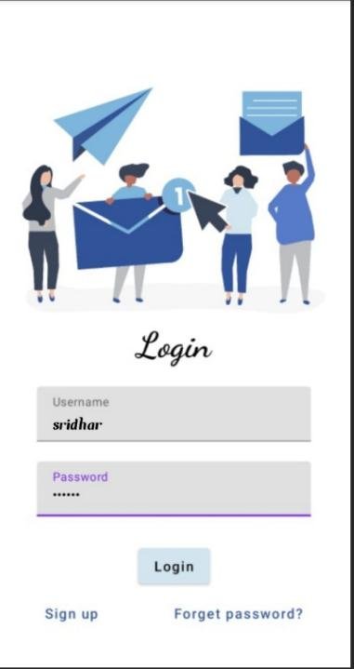

Login :

The user should enter a correct details to login

# GOOGLE DEVELOPER PROFILE PUBLIC URL

Team leader–

# <https://g.dev/Sridhar12>

# Team member 1

# <http://g.dev/Pavansai1903>

# Team member 2

# <https://g.dev/Nethraj1>

# Team member 3

# <https://g.dev/Gokulakannan123>

1. **ADVANTAGES & DISADVANTAGE**

# Advantages :

* Messages can be accessed from various computers or mobile devices at different locations, using different clients.
* Some kind of backup is usually provided by the server.

# Disadvantages :

* With limited bandwidth, access to long messages can be lengthy, unless the email client caches a local copy.
* There may be privacy concerns since messages that stay on the server at all times have more chances to be casually accessed

# APPLICATIONS

This application is used in Publishing Email, messages are available easily without any searches.

1. **CONCLUSION**

# In a formal business document, the conclusion ties together your main ideas. Most emails, though, do not require a formal conclusion. Often a concluding paragraph consists of just a sentence or two in which, for example, the writer thanks the recipient or offers assistance.

1. **FUTURE SCOPE**

 The interesting thing about email is that even though it is such a critical utility, there is very little consumer choice of email services available. In fact, only three email services that are more than 20 years old own [91%](https://www.litmus.com/blog/email-client-market-share-2021-q1/" \t "_blank" \o "https://www.litmus.com/blog/email-client-market-share-2021-q1/) of the u.s. email market (and likely the bulk worldwide): gmail, yahoo mail and microsoft outlook.